Smart Water Fountain

# Problem Definition:

Start by identifying the problem you want to address with smart water fountains. Is it water conservation, accessibility, or something else?

Highlight the importance of clean and accessible drinking water in public spaces.

Discuss any existing issues with traditional water fountains, like hygiene concerns or water wastage. Mention the potential health and environmental benefits of tackling this problem.

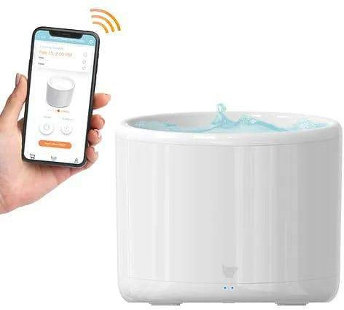

# Design Thinking:

Explain the principles of design thinking, such as empathy, ideation, and prototyping.

Apply design thinking to your smart water fountain project by emphasizing user-centered design.

Discuss how you conducted user research to understand the needs and preferences of the target audience.

Describe the ideation process, including brainstorming solutions and creating user personas. Highlight how prototyping and testing were used to refine the design.

# Innovation and Problem Solving on IoT Platform:

Explain how IoT (Internet of Things) technology can be integrated into smart water fountains.

Discuss the innovative features and capabilities your smart water fountain offers, such as real-time water quality monitoring, touchless operation, or water consumption data collection.

Address how the IoT platform enhances problem-solving by providing data insights and remote management.

Mention any challenges encountered during the implementation of IoT technology and how they were overcome.

Highlight the potential for scalability and future innovations in this field, such as predictive maintenance or smart city integration.

Remember to provide real-world examples or case studies if available, and use data or statistics to support your points where relevant.